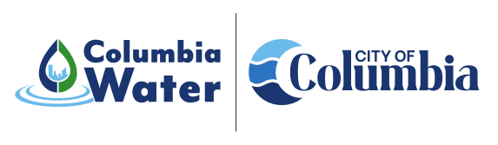
Canal Recovery
Projects
Canal Headgate Replacement Project
Project Description: | 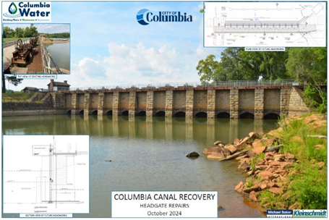  The project involves the replacement of twelve existing headgates that were damaged during Hurricane Joaquin and the subsequent flooding in October of 2015. Specific project components include removal of temporary bulk-heads, installation of new gates and operators, installation of rock anchors for structural stability and deployment of a trash rack for debris collection. This project is a significant step to returning the Columbia Canal to pre-disaster condition and operation for water supply and hydroelectric generation.
Objectives: | To restore the headgate structure and equipment for the historic Columbia Canal to pre-disaster condition and operability for water supply and hydroelectric generation.
Project Type: | 2015 Flood Recovery – Drinking Water Source
Council District: | System-wide generally
Project Funding: | This project is being funded through a combination of the City’s capital improvement program and $5.6M of award from a Housing and Urban Development – Community Development Block Mitigation Grant. The estimated construction cost is approximately $12M.
Current  Project Status: | The project is currently in the final stages of permitting and is anticipated to move to the bidding phase in the late summer of 2025. The estimated project duration is 15 months.
Project Contacts: | Gregory Tucker  Special Projects Manager  803.545.4309 | Gregory.Tucker@columbiasc.gov  Benjamin Wildt  Columbia Water Communications Manager  803.545.0466 | blwildt@columbiasc.gov

