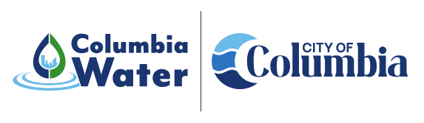
Canal Recovery
Projects
Canal Embankment Repair Project
Project Description: | 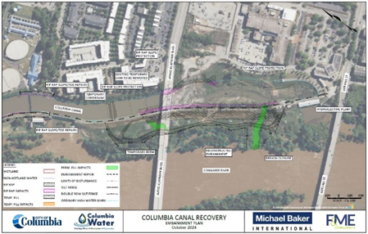  The project involves the repair of the historic Columbia Canal from the damage from Hurricane Joaquin and the subsequent flooding in October of 2015. Specific project components include removal of the existing rock dam, reconstruction of breach area, repair of damage to the embankment toe and slope, renovation of the hydroelectric generating station, repair of Riverfront Park facilities and documentation of historical features. The project is a significant step to returning the Columbia Canal to pre-disaster condition and operation for water supply and hydroelectric generation.
Objectives: | To return the historic Columbia Canal to pre-disaster condition and operability for water supply and hydroelectric generation.
Project Type: | 2015 Flood Recovery – Drinking Water Source
Council District: | System-wide generally
Project Funding: | This project is being funded through a combination of awards from the Federal Emergency Management Agency Public Assistance Program and the South Carolina Emergency Management Division. The estimated construction cost is approximately $60M.
Current  Project Status: | The project is currently in the final stages of permitting and is anticipated to move to the bidding phase in the fall of 2025. The estimated project duration is 27 months.
Project Contacts: | Gregory Tucker  Special Projects Manager  803.545.4309 | Gregory.Tucker@columbiasc.gov  Benjamin Wildt  Columbia Water Communications Manager  803.545.0466 | blwildt@columbiasc.gov

